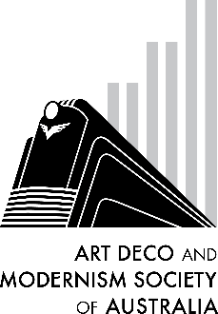

**The Art Deco and Modernism Society of Australia**

**presents**

|  |  |  |
| --- | --- | --- |
|  | **Seattle – From Deco to Mid-Century**  Surrounded by water, mountains and evergreen forests, Seattle’s nature and architecture pack a punch. Following the recent US 20th Century Design tour of Seattle, join us for a guided tour of the 2 largest cities in the American Northwest. Washington State’s largest city, Seattle, has a rich history of pioneering spirit that crafted an Art Deco smorgasbord through to the pinnacle of Mid-Century marvels.  Just a few hours south, Oregon’s largest city, Portland, shares the dramatic landscape, and boasts its own share of stunning Deco, even though it hasn’t quite kept pace with Seattle’s caffeine-fuelled high tech boom.  Three ADMSA Committee members joined the tour in October 2024 and are excited to share their best pics and stories. |  |

**Date: Thursday 6 February 2025**

**Time: 7:45 pm for 8:00 pm start**

Venue: The Glasshouse Caulfield (in Caulfield Racecourse)

31 Station Street Caulfield East 3145

———————————————————————————————————————————

**Booking and payment by Monday 3 February 2025**

Number of members at $20: _____________ Number of non-members at $25 ______________

Name(s): _________________________________________________________________________________

_________________________________________________________________________________________

Tel: ______________ Email: _______________________________________________________

⬜ EFT: Westpac BSB: 033-048 Account: 851024 and email transaction to the Secretary robynsaalfield@ihug.com.au

⬜ Cheque or money order payable to Art Deco and Modernism Society of Australia Inc.

Credit card ⬜ Visa ⬜ MasterCard

Card number: ⬜⬜⬜⬜ ⬜⬜⬜⬜ ⬜⬜⬜⬜ ⬜⬜⬜⬜ Expiry date: ______/______

Cardholder’s name: ______________________________________________________________

Amount: $ ____________ Signature: ________________________________________________

* email: [robynsaalfield@ihug.com.au](mailto:robynsaalfield@ihug.com.au)
* mail: to Art Deco and Modernism Society of Australia Inc PO Box 17 CAMBERWELL VIC 3124

Art Deco and Modernism Society of Australia Inc is an Incorporated Association pursuant to the *Associations Incorporation Act 1981 (Vic)*

[www.artdeco.org.au](http://www.artdeco.org.au)